**DAILY ONLINE ACTIVITIES SUMMARY**

|  |  |  |  |  |  |  |
| --- | --- | --- | --- | --- | --- | --- |
| **Date:** | **25/06/2020** | | | **Name:** | **Apoorva K N** | |
| **Sem & Sec** | **6th sem & A sec** | | | **USN:** | **4AL17CS012** | |
| **Pre-Placement Training Summary** | | | | | | |
| **Pre placement training** | **9:00 am to 11:00 am - JSP**  **11:00 am to 1:00pm - Datastructures in C** | | | | | |
| **Faculty** | | **Mr. Sayeesh**  **Mr. Venkatesh Bhat** | **Duration** | | | **4 hr** |
| **Assessments** | | | | | | |
| 1. **C program to implement simple queue using SLL.** 2. **C program to implement circular queue using SLL.** 3. **C program to implement multiple stack operation using SLL.** 4. **C program to implement operations on multiple queue.** | | | | | | |
| **Status: Completed** | | | | | | |
| **Uploaded the report in Github** | | | **Yes** | | | |
| **If yes Repository name** | | | <https://github.com/Apoorva-K-N/pre-placement-training> | | | |
| **Uploaded the report in slack** | | | **Yes** | | | |

**Training snapshots:**

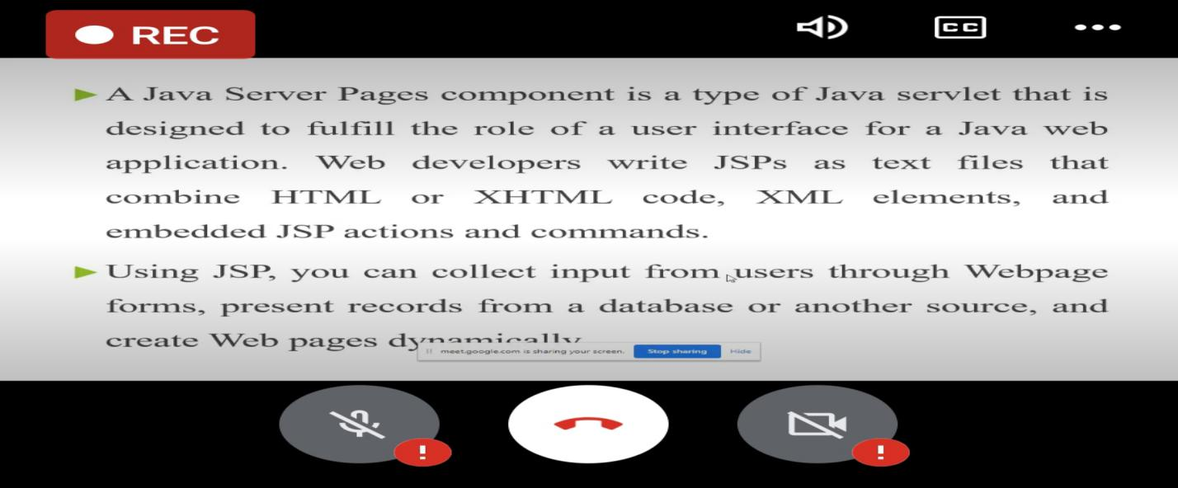

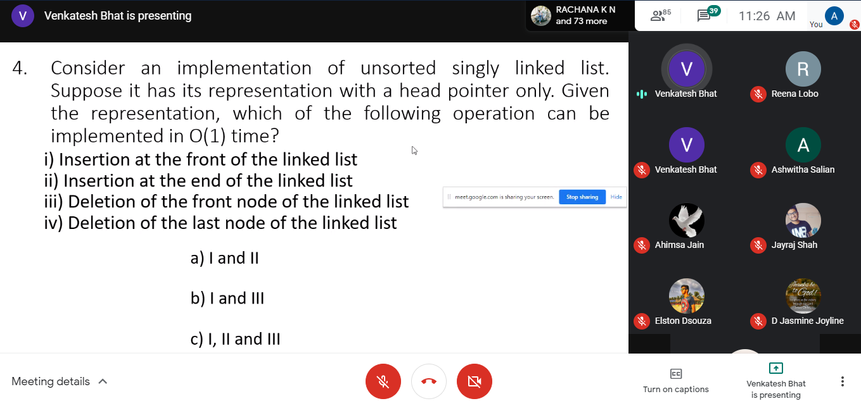

**Assessments:**

**The assessment is uploaded in github repository and the link is given below:**

<https://github.com/Apoorva-K-N/pre-placement-training>